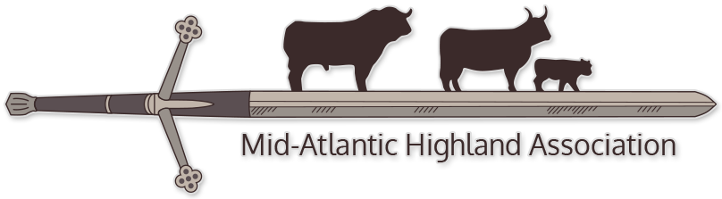

BREEDERS' ONLINE AUCTION TERMS
This will be an online only sale. Consignments can be submitted via email to midatlantichighlands@gmail.com until July 1st. Those consigning animals will need to provide photos and videos of the cattle for the sale website. Cattle with ship directly from the consignor’s farm. Buyer is responsible for shipping. Commission levels are 8% for live animal sales & semen and 4% for no sales.
ENTRIES: Consignments will be accepted on a first-come, first-served basis. The committee reserves the right to determine the final lots and the lot order. We will accept no more than 20 females nor more than 5 semen lots. Unregistered stock will be considered after registered stock. Entries may include cows, bred or with calf at side, open heifer calves, or semen. No steers, no bulls.
FEES: $50 for non MAHA Members, $20 for current MAHA Members. Entry fees are non-refundable. The last bid received via the online sale constitutes the basis for the commission charge, which is in addition to the entry fee. Animals who are sold will be charged 8% commission. Animals who do not meet the reserve set by the seller will be charged 4% of the last bid placed on the animal. Any animals withdrawn after July 20 , 2022 will be assessed a $100 cancelation fee, in addition to the entry fee they already paid. Substitution of equal quality will be allowed on a case by case basis.
ONLINE AUCTION: MAHA will be providing Live all sales using the services of Cowbuyer.com. Consigners are encouraged to submit videos of consigned animals by July 1st These videos will be used to advertise your cattle. All cattle should be preferably halter trained, in top condition, and groomed. Cattle of sound disposition, but not halter trained will be considered. Wild or poorly behaved animals will not be tolerated, nor accepted.
HEALTH REQUIREMENTS: Seller offers the animals in good faith that the animals or semen are as represented and are solely responsible for the condition of the lots offered in the online auction. Seller will provide an vaccination schedule to the Buyer. Seller will have the animal up to date on all vaccinations including but not limited to BVD and Brucellosis.
Seller is responsible for obtaining a health certificate for any animals sold out of state at Seller’s cost. Sellers consigning animals to the sale are responsible for providing the health papers for travel to the Buyers. These Health Certificates (CVI) will be provided to ALL buyers regardless if within State travel. CVI must be written no more than 30 days prior to pickup and must meet the requirements of the Buyers State Importation regulations, giving enough time to complete any bloodwork or testing required by the Department o Agriculture of Buyers State. Any advertised bred or exposed cow/heifer will provide proof of pregnancy check and confirmation. Seller must also submit the transfer papers to AHCA no less than 30 days after the pick up of the animal
All animals will ship directly from your farm. You will be responsible to work with the buyer to arrange pick up/shipment. . Buyers must take possession of cattle within 30 days of the close of the auction. If you would like to offer to keep your cattle for a longer period of time, you need to work out any arrangements with the buyer .Buyer is responsible for the cost of shipping and arranging transportation.
Mid Atlantic Highland Cattle Association, its Board Members and its membership are not liable for the misrepresentation of any lot offered in the Online Sale. If you have further questions, please contact Jim Lindauer or Heather Sheppard Lunn at Midatlantichighlands@gmail.com

BREEDERS' ONLINE AUCTION

Please fill out ALL information and submit online to midatlantichighlands@gmail.com
Farm/Ranch Name:______________________________________________
OWNER:__________________________________________________________
Mailing Address:_________________________________________________
City:_____________________________State:________ZIP:______________
Phone:_____________________Secondary Phone:_____________________
Email:_________________________________________________________
Make Check Payable to :____________________________________________

Submitting ___ Lots (initially we ask no more than 2 live lots)
Bred Cow_____ Bred Heifer:_____ Open Cow:______ Open Heifer:_______
Semen:______
Animals are: Registered or Unregistered

Mid-Atlantic Highland Cattle Association's Breeders Auction
CONSIGNMENT FORM, fill out one per lot:
Consignor:_____________________________________________________
Breeder:________________________________________________________
Name of Animal:__________________________________________________
Registration number: ____________________ Tattoo:__________________
Date of Birth:__________________________Color:_______________________
Dam:___________________________________________Reg #_____________________
Sire:___________________________________________Reg#_______________________
Bred to: (if applicable)____________________________________Reg#:____________
*AI or Pasture exposure *Projected due date:(if Known)
_______________________ ________________________________
Calf at Side:(if applicable)
*DOB:_____________________ *Registration #:________________
*Sire:______________________ *Color:________________________
*Birth weight:______________ *Tattoo_________________________
All calves sold at side must have pending or registered status. Seller to decide if bull calves will be steered. Calves cannot be registered by Buyer if not already registered. All tattooing and registration will be done by seller.
Reserve Price (if desired):_____________________(note: if reserve not met, Seller will be charged 4% of final listed bid)
Description:(for marketing your animal)

A copy of the registration(s) must accompany each lot.

